ONEWAY CS BY WOKE
/STATISTICS DESCRIPTIVES HOMOGENEITY WELCH
/PLOT MEANS
/MISSING ANALYSIS.

Oneway

Notes
Output Created |  | 05-May-2019 23:48:02
Comments
Input | Active Dataset | DataSet0
Input | Filter | <none>
Input | Weight | <none>
Input | Split File | <none>
Input | N of Rows in Working Data File | 30
Missing Value Handling | Definition of Missing | User-defined missing values are treated as missing.
Missing Value Handling | Cases Used | Statistics for each analysis are based on cases with no missing data for any variable in the analysis.
Syntax |  | ONEWAY CS BY WOKE  /STATISTICS DESCRIPTIVES HOMOGENEITY WELCH  /PLOT MEANS  /MISSING ANALYSIS.
Resources | Processor Time | 00 00:00:00.156
Resources | Elapsed Time | 00 00:00:00.155

[DataSet0]

Descriptives
 | N | Mean | Std. Deviation | Std. Error
Between 1-4 hours | 5 | 36.6000 | 3.13050 | 1.40000
Between 4-6 hours | 9 | 37.8889 | 4.37163 | 1.45721
Between than 6-8 hours | 3 | 40.0000 | .00000 | .00000
More than 8 hours | 13 | 39.0769 | 1.75412 | .48650
Total | 30 | 38.4000 | 3.00115 | .54793

Descriptives
 | 95% Confidence Interval for Mean |  | Minimum | Maximum
 | Lower Bound | Upper Bound | Minimum | Maximum
Between 1-4 hours | 32.7130 | 40.4870 | 34.00 | 40.00
Between 4-6 hours | 34.5286 | 41.2492 | 28.00 | 40.00
Between than 6-8 hours | 40.0000 | 40.0000 | 40.00 | 40.00
More than 8 hours | 38.0169 | 40.1369 | 36.00 | 40.00
Total | 37.2794 | 39.5206 | 28.00 | 40.00

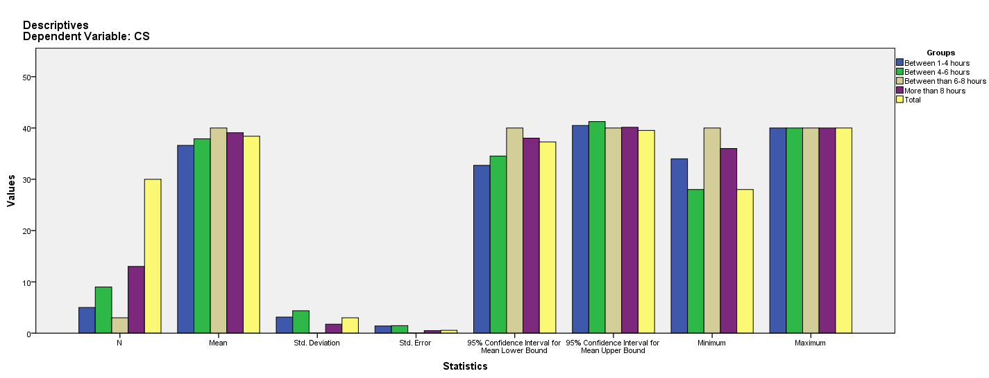

Test of Homogeneity of Variances
CS
Levene Statistic | df1 | df2 | Sig.
4.250 | 3 | 26 | .014

ANOVA
CS
 | Sum of Squares | df | Mean Square | F | Sig.
Between Groups | 32.188 | 3 | 10.729 | 1.218 | .323
Within Groups | 229.012 | 26 | 8.808
Total | 261.200 | 29

Robust Tests of Equality of Means^{b}
CS
 | Statisticª | df1 | df2 | Sig.
Welch | . | . | . | .
a. Asymptotically F distributed.
b. Robust tests of equality of means cannot be performed for CS because at least one group has 0 variance.

Means Plots

